**Assignment-2**

|  |  |
| --- | --- |
| **Customer** | |
| **Customer_Id** | **Customer_Name** |
| 1 | John |
| 2 | Smith |
| 3 | Ricky |
| 4 | Walsh |
| 5 | Stefen |
| 6 | Fleming |
| 7 | Thomson |
| 8 | David |

|  |  |  |
| --- | --- | --- |
| **Product** | | |
| **Product_Id** | **Product_Name** | **Product_Price** |
| 1 | Television | 19000 |
| 2 | DVD | 3600 |
| 3 | Washing Machine | 7600 |
| 4 | Computer | 35900 |
| 5 | Ipod | 3210 |
| 6 | Panasonic Phone | 2100 |
| 7 | Chair | 360 |
| 8 | Table | 490 |
| 9 | Sound System | 12050 |
| 10 | Home Theatre | 19350 |

|  |  |  |
| --- | --- | --- |
| **Order** | | |
| **Order_Id** | **Customer_Id** | **Ordered_Date** |
| 1 | 4 | 10-Jan-05 |
| 2 | 2 | 10-Feb-06 |
| 3 | 3 | 20-Mar-05 |
| 4 | 3 | 10-Mar-06 |
| 5 | 1 | 5-Apr-07 |
| 6 | 7 | 13-Dec-06 |
| 7 | 6 | 13-Mar-08 |
| 8 | 6 | 29-Nov-04 |
| 9 | 5 | 13-Jan-05 |
| 10 | 1 | 12-Dep-2007 |

|  |  |  |  |
| --- | --- | --- | --- |
| **Order_Details** | | | |
| **Order_Detail_Id** | **Order_Id** | **Product_Id** | **Quantity** |
| 1 | 1 | 3 | 1 |
| 2 | 1 | 2 | 3 |
| 3 | 2 | 10 | 2 |
| 4 | 3 | 7 | 10 |
| 5 | 3 | 4 | 2 |
| 6 | 3 | 5 | 4 |
| 7 | 4 | 3 | 1 |
| 8 | 5 | 1 | 2 |
| 9 | 5 | 2 | 1 |
| 10 | 6 | 5 | 1 |
| 11 | 7 | 6 | 1 |
| 12 | 8 | 10 | 2 |
| 13 | 8 | 3 | 1 |
| 14 | 9 | 10 | 3 |
| 15 | 10 | 1 | 1 |

1. Fetch **all the** Customer Details along with the product names that the customer has ordered.

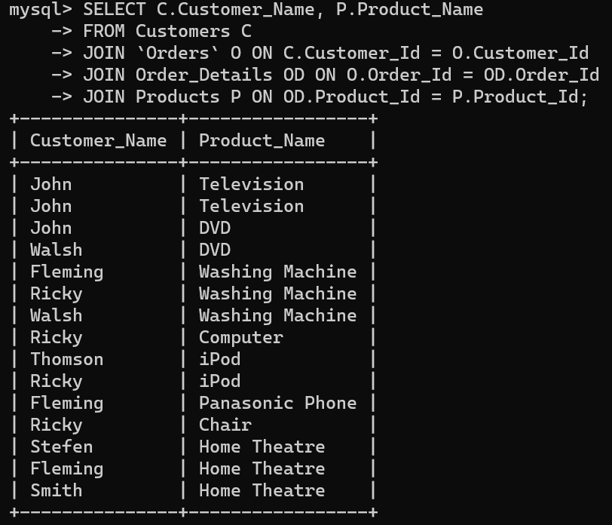

1. Fetch Order_Id, Ordered_Date, Total Price of the order (product price*qty).

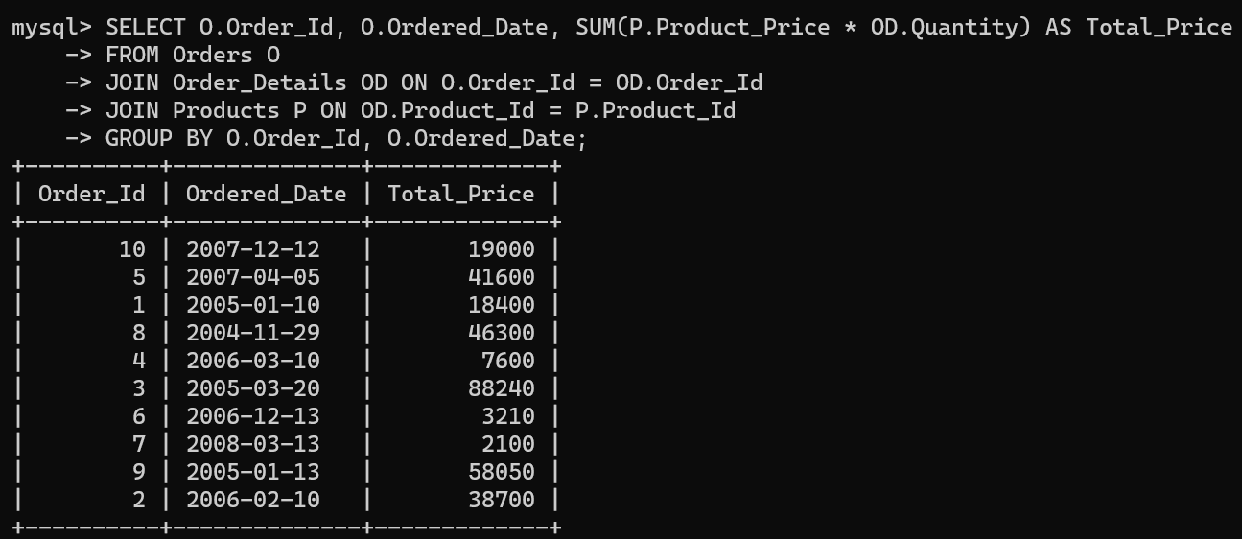

1. Fetch the Customer Name, who has not placed any order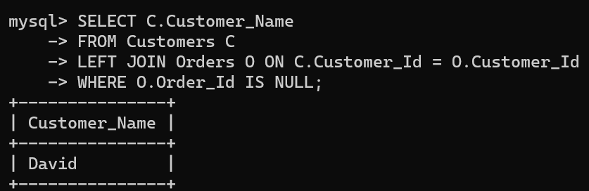

1. Fetch the Product Details without any order(purchase)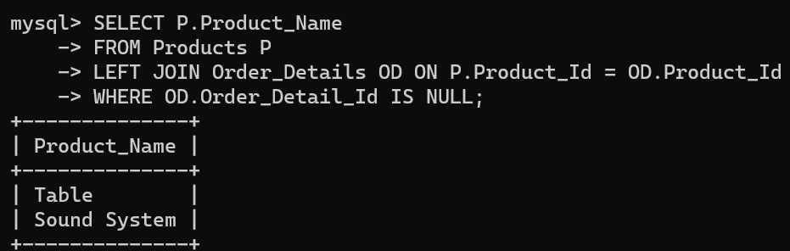

1. Fetch the Customer name along with the total Purchase Amount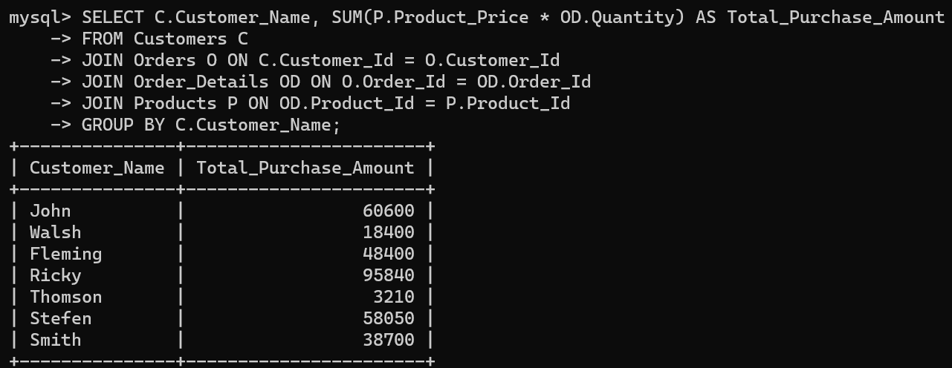

1. Fetch the Customer details, who has placed the first and last order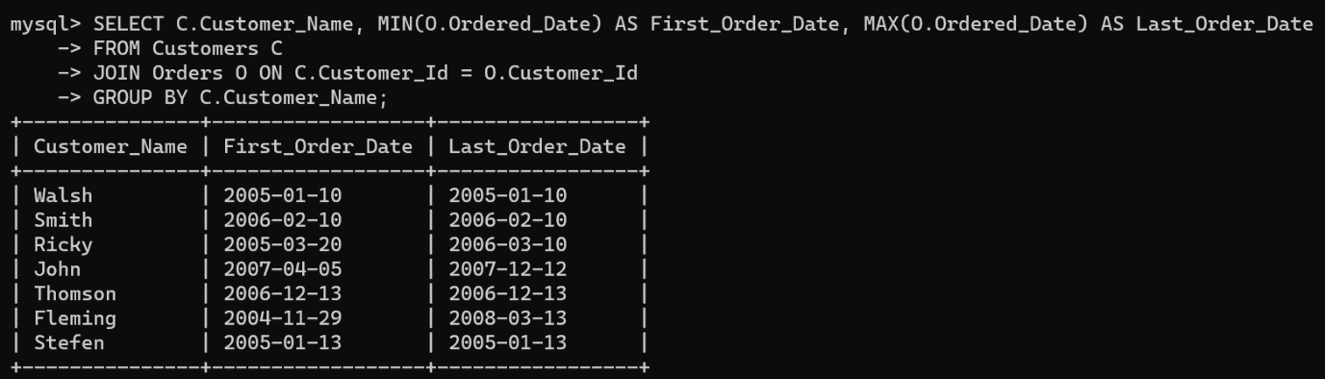

1. Fetch the customer details , who has placed more number of orders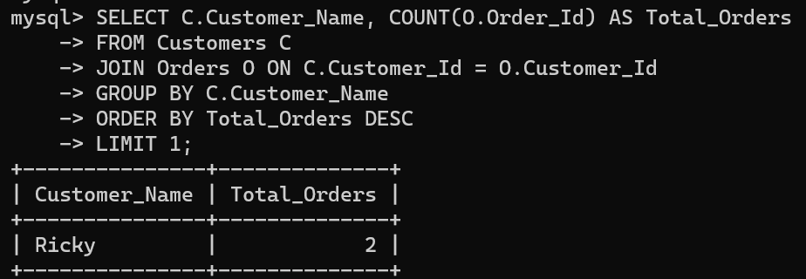

1. Fetch the customer details, who has placed multiple orders in the same year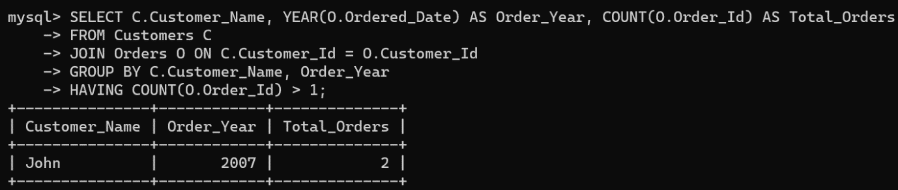

1. Fetch the name of the month, in which more number of orders has been placed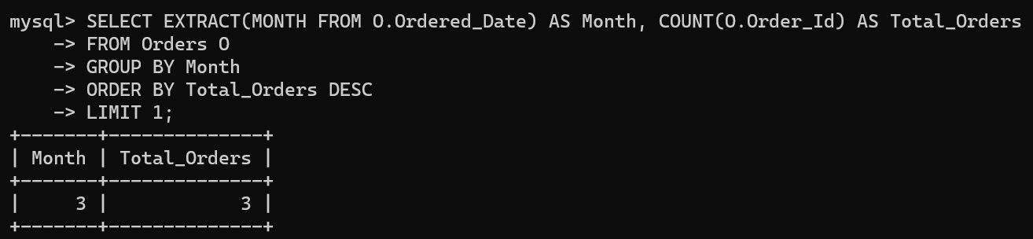

1. Fetch the maximum priced **Ordered Product**